Crawl the real male and female users of the same city dating site in each province, and do the analysis
Crawl member ID, nickname, age, province, city, constellation, education, profile picture, monthly salary, marriage status, height, weight
The data uses the data in the data folder, which has the male data and the female data
1. Get the total data of male and female students
2. Analyze the ratio of boys to girls in each region
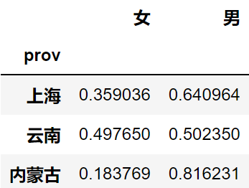

3. Check the top five zodiac signs for the most dating posts
4. See which 10 ages have the most dating needs (filter out all invalid data)
5. Get the number of men and women of all ages
6. The proportion of each degree
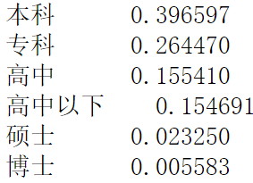

7. Come up with the top 10 cities with the highest average educational attainment
Those without a diploma have a high school diploma or less by default
Let's say the full score for a degree is 100
30 points for junior high school, 40 points for senior high school, 50 points for junior college, 60 points for undergraduate, 70 points for master and 80 points for Doctor
8. Get the top 10 provinces with the most physically fit people
Results were obtained according to BMI
According to the ratio: 70kg÷ (1.75×1.75) =22.86
Results between 18.5 and 23.9 belong to the standard body shape
9. Look at the top 10 provinces for salaries
Salary is confidential,0, null value will not be calculated
Take the average of the salary over the range
Those above 50000 shall be deemed 50000 and those below 2000 shall be deemed 2000
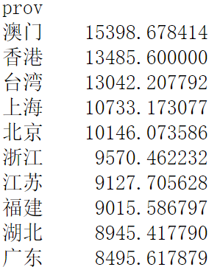

3. Height and weight scatter plot
3. Top10 provinces with highest salaries (choose any picture)
3. Top 10 provinces with the highest number of people meeting BMI (bar chart, similar effect)

